IS 340 Operating Systems

**HP04A Installing Type 2 Hypervisor - Oracle VirtualBox**

07/10/2019 Developed by Kevin Kuanting Chen

07/16/2019 Reviewed by Apiwat Chuaphan and Clark Ngo

06/17/2019 Reviewed by Kim Nguyen

Center for Information Assurance Education (CIAE) @City University of Seattle (CityU)

|  |
| --- |
| C:\Users\chungsam\AppData\Local\Microsoft\Windows\INetCache\Content.MSO\C47DD46.tmp |

**Installing VirtualBox on Windows 10**

1. Download VirtualBox
   1. Visit <https://www.virtualbox.org/wiki/Downloads>
   2. Download VirtualBox for Windows by pressing the Windows hosts link.

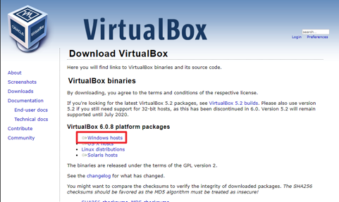

1. Install VirtualBox
   1. Double-click the Downloaded file to install VirtualBox.
   2. On the first page, click Next.
   3. Change the install location or accept the default location and click next.

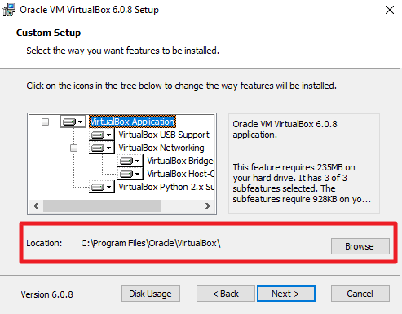

* 1. Proceed to the warning page, read the warning message, and click Yes when you are ready.

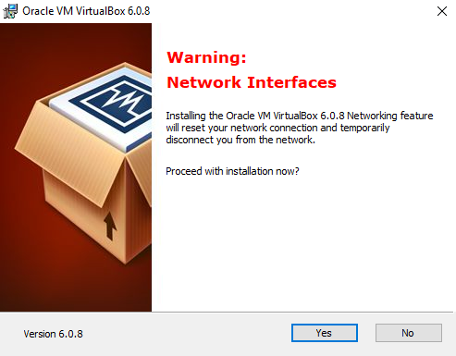

* 1. On the next page, click Install. Allow the software to make change to your device and click install if Windows security prompt.

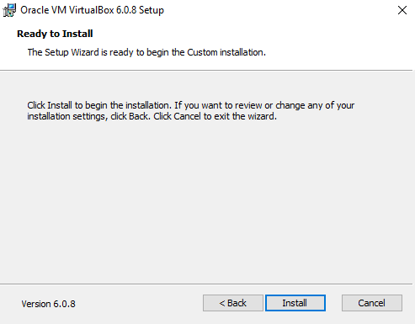

* 1. Wait until the installation is done and press Finish.

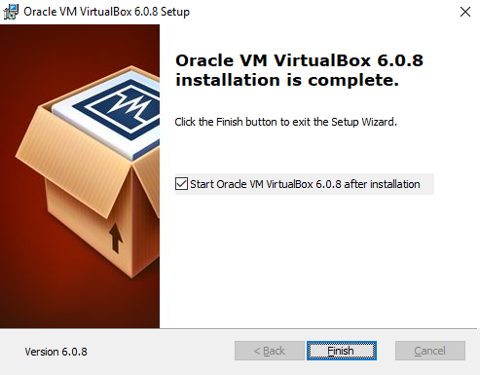

* 1. You can then explore the Oracle VM VirtualBox Manager.

